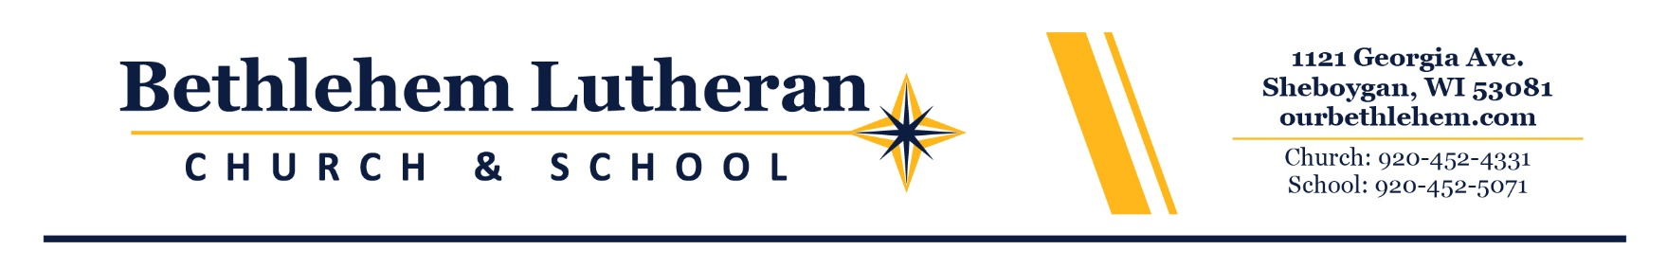
Bethlehem Lutheran School Food Service Program

Dear Parent or Guardian: USDA Policy Memorandum SP 46-2016 requires all School Food Authorities (SFAs) operating federal school meal programs to have a written and clearly communicated policy to address unpaid meal charges by July 1, 2017.

Lunch Account Guidelines
Bethlehem Lutheran School understands the importance of serving nutritious meals daily to our students. If meals are purchased through the school nutrition program, it is the parent/guardian’s responsibility to keep a positive account balance in the students account. In order to provide clarity and accountability surrounding the school nutrition program, the following procedures regarding student meal account balances have been put in place:

A notice will be sent out on Wednesdays through email to the family letting them know if their lunch reaches a positive $10.00 or less balance asking them to deposit money into their account.

No a la carte items may be purchased on account if there is a negative account balance.

When an account is in the negative, the student will receive a letter home informing them of the balance due on their account and requires immediate payment.

ANY STUDENTS WITH A NEGATIVE ACCOUNT BALANCE GREATER THAN -$30.00 WILL NOT RECEIVE THE DAILY SCHEDULED HOT LUNCH OR A MILK. We will make sure that students are offered an alternate entrée, such as a Turkey or Ham and cheese sandwich, a carton of milk and a fruit.

It is not the intent of the school or the food service staff to punish or embarrass any student. Parents please do not put your child in the awkward position of not having money for meals. There are many ways to avoid consequence of this policy.

Parents are encouraged to apply for free and reduced meal assistance if there is a need. Please contact the school office if you are in need of a free and reduced application or email amy.morrelle@ourbethlehem.com.

Parents are required to maintain a positive balance in their Family School Lunch Account. The lunch account is NOT A CREDIT CARD. It is recommended that accounts maintain a minimum balance of $5.00 PER STUDENT.

At the end of the school year, if a family no longer has children attending school the family will receive a complete refund of all money left in the student’s lunch account.

Funds may be donated to an account to help other families. A request must be made in writing by June 10, to help those accounts with a negative fund. If you wish to donate any funds remaining please contact Amy Morrelle at amy.morrelle@ourbethlehem.com.

Eighth graders with negative balances in the family lunch account must pay in full prior to participating in graduation ceremonies. Graduating eighth graders or withdrawing students will be refunded after the student’s last day of school.

In accordance with Federal civil rights law and U.S. Department of Agriculture (USDA) civil rights regulations and policies, the USDA, its Agencies, offices, and employees, and institutions participating in or administering USDA programs are prohibited from discriminating based on race,
color, national origin, sex, disability, age, or reprisal or retaliation for prior civil rights activity in any program or activity conducted or funded by USDA.

Persons with disabilities who require alternative means of communication for program information (e.g. Braille, large print, audiotape, American Sign Language, etc.), should contact the Agency (State or local) where they applied for benefits. Individuals who are deaf, hard of hearing or have speech disabilities may contact USDA through the Federal Relay Service at (800) 877-8339. Additionally, program information may be made available in languages other than English.

To file a program complaint of discrimination, complete the USDA Program Discrimination Complaint Form, (AD-3027) found online at: http://www.ascr.usda.gov/complaint_filing_cust.html, and at any USDA office, or write a letter addressed to USDA and provide in the letter all of the information requested in the form. To request a copy of the complaint form, call (866) 632-9992. Submit your completed form or letter to USDA by:

(1) mail: U.S. Department of Agriculture
Office of the Assistant Secretary for Civil Rights
1400 Independence Avenue, SW
Washington, D.C. 20250-9410;

(2) fax: (202) 690-7442; or

(3) email: program.intake@usda.gov.

This institution is an equal opportunity provider.

